Welcome
After one year study leave with three months of visiting churches, partners, and friends in the USA, we returned at the end of October to a joyful welcomed of warm greetings and smiles from my husband, friends, and mission station family. Thankful to be ‘home’
Thanks to Rev. Jerry Kandea, who served in our absent as acting superintendent and the Mission Station Council who provided leadership when we were away.

Homecoming/ Celebration
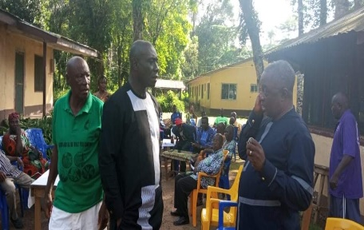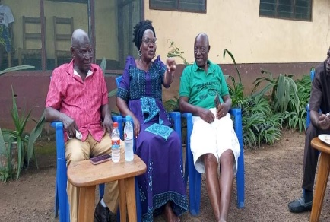
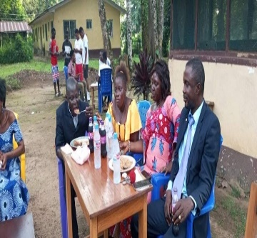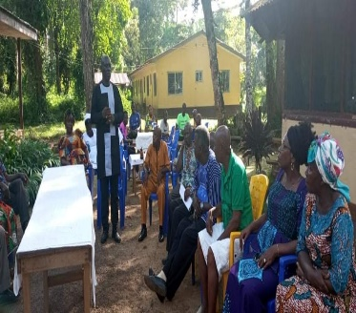
We retuned with an excitement and a vision for local pig farmers to find market for them in order to produce hog/pork meat for local market for sustainability.
The first meeting was held on Saturday, November 19, 2022, with 20 participants and discussed:
Fining Market for pig farmers
Adding-value to productions
Forming Co-operatives for pig farmers
The pig framers did embrace the idea and looking forward to work together as farmers.
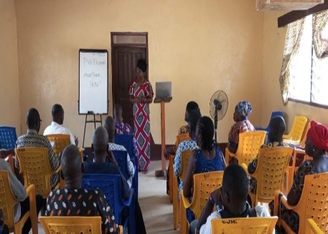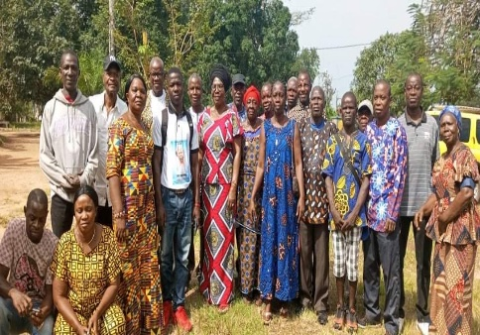
The participants discussing on forming a Co-cooperative!
It is a blessing to see God working to build hope in the lives of men women, and young people through education, health, and a sustainable agriculture program, thanks to all our partners for the support.
Thank you, our partners, and friends, for being with us in mission and ministry and for continued generosity giving from your resources making mission possible. We give all glory to God!!

The 81st Capping/ Stripping & Candle Lighting of 65 nursing students from the Winnifred J. Harley College of Sciences November 5, 2022 in Ganta, Liberia.
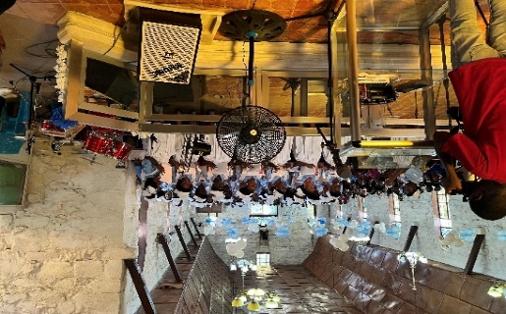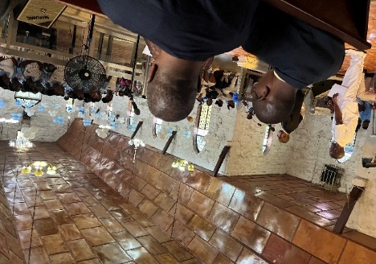
The Gipo Vocational Training Institute/Academic opened in October 2022 with an enrollment of 220 students ABC-7th grade. This a great improvement in the enrollment from 2020 during to Covid and some traditional practice been going in the villages.
Children are very excited to be in school but challenges are: space for the number students and getting teachers who are will to live in villages to teach. The elementary classes ACB, K-1& K2 all are into one class room with one teacher. The school wishes to have separate rooms and to hire two more teachers but have some financial challenges.
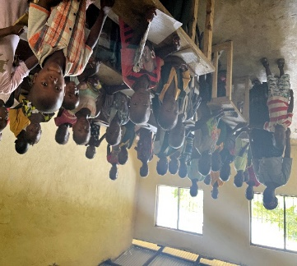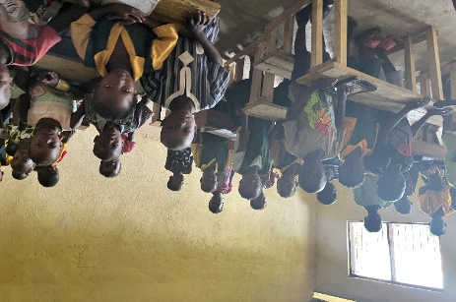
Thanks for the generosity of friends and churches who are sponsoring some pf our students which keeping them in school. Sponsors: Ann & Jay Anderson, 2students, Cross winds 4students. , Minnesota Conference, Charles and Janice Gallaher, 3students, Elizabeth Lee Chickamauga, GA.31students, St. John UMC, , IL Great River Conference, North Carolina Conference 48students The Ganta United Methodist School: We’re grateful for to you, education wouldn’t otherwise be possible if it was not for you providing scholarship for our students. Because most of the students attending school parents in poverty and unable to put them through school
Ganta United Methodist Students, during morning devotion:
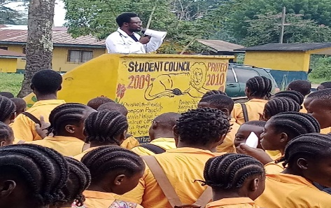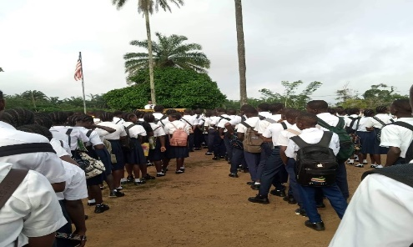
Each morning, the teachers and students begin with devotions, and bible is taught in the school as one of the subjects. Students are to attend Sunday school every Sunday at 9am.
The Long Waiting Day / an investigative Survey: The Court order that an investigative survey be done on the Ganta Mission Station Land that been encroachment on by one Fred Suah. The case has been in court since 2017, the three days exercised was exhausting but worthy. we have prayed and long been waiting for this day to come and it was completed without any violence, God answered our prayers. Thanks to Cllr. James N. Gilayeneh, our lawyer for his efforts and time on this complicated case without charging any legal fees. The whole of Ganta community and elders of the town who gave the land to Dr. George Way-Harley in 1926, children were present and to witness the survey. Please pray with us for justice to prevail, that the land be given back to the church for the purpose it was given, for mission and ministries. The challenge now is seeking for justice in Liberia bribery is very high and you can be denied of justice in the face of that. The goal now is to raise $12,000 for the surveyor’s fees. Our Thanks and appreciation to Bishop Samuel Quire and the Liberia Annual for the contortion of $3,000. The Ganta mission station has raised $4,000 of the amount balance now is $5,000 to raise. The fees need to be paid by December 15,2022. We are praying and asking our friends to help us raise this amount to save the land. “SOS Call”
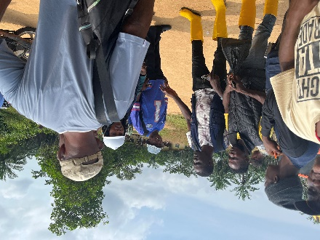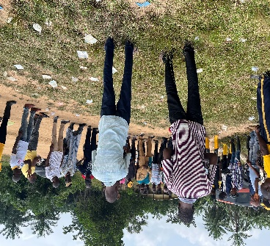

The Liberia Land Authority / Surveyors Prayer is said by one of the elders, for God’s intervention
peace and justice to prevail
#Giving Tuesday: Give to Global Ministries! During this #GivingTuesday from December1 31. I’m asking that you our partners and friends support me with your prayers and let 10% of your giving be for my support as your missionary.
Go to! https://umcmission.org/givelove/#givelove
The goal, is to raise $75,000! Through this we are able to help make a difference and bring joy, hope, love and peace to those who are vulnerable. Your donation will support:
- Ganta Mission Station Land survey
- Scholarship support for grade students
- Dormitory construction, to house girls in a safe environment
- Sustainable Agriculture -pig farmers, slaughterhouse plant building/ refrigeration cooling for meat production
- Hospital, health service
- Advance #14369T
- My salary support-Advance # 13035Z

In mission together,
Priscilla (Jaiah) Gilayeneh
GBGM Missionary
Ganta Mission Station Superintendent

