REV. PRISCILLA LEGAY-GILAYENEH
GLOBAL MINISTRIES MISSIONARY ASSIGNED TO LIBERIA
GANTA UNITED METHODIST MISSION STATION
November-/December, 2020 NEWSLETTER THANGSGIVING/ADVENT
Advance Special: #14369T
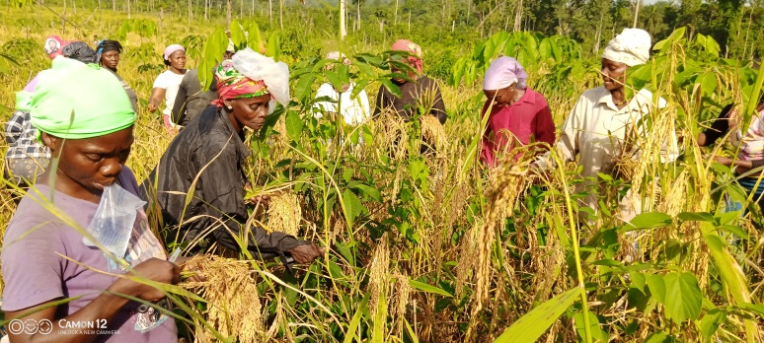
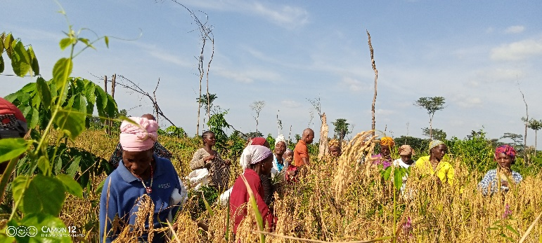
Email: pjaiah12@gmail.co
FROM LABOR TO HAVEST, The women farmers are united and cooperatively working together as a group for Food Security in Liberia. The group composed of 25 women harvesting up land rice with great joy.

Thanks to our friends and partners for your generosity, love and support toward our ministry here at the Ganta Mission Station. Every dollar you've donated and plan to give has tremendous impacts; just to mention few of your donations impacts on our ministry, scholarship sponsorship to our grade and college students, affordable and quality healthcare delivery services for extremely poverty-stricken families in northeastern Liberia, rural Guinea, and the Ivory Coast even during this Covid-19 crisis, Support of the nursing school, agriculture and Vocational education in the Gipo Village.
During this year Advent Journey, I’m holding in my heart friends, partners and family members as I reflect on Advent in a different perspective. I view advent as something already here not a season waiting to arrive. I have read all long that it is a time for waiting and preparation for the arrival of our Jesus Christ, into the world.
Reading Matthew 1:23, Matthew Gospel speaks of Jesus as Emmanuel, which means “God is with us.” This name doesn’t speak of the future, but of the present; in spite of our present challenges, as we face the greatest health crisis in the world, with Covid-19 pandemic this 2020. Our hope is in God. This advent season let us dare to embrace the hope of Jesus right now, Knowing that God’s grace and love are present and will carry us through the most challenging times in our life. This is a time when we can rejoice and give praise for the fulfillment of scripture, Emmanuel “God is with us.”
At the Ganta mission Station things has been challenging but didn’t stop the ministry totally with the prayers of our partners and support.
THE DAY OF HAVEST:
The local farmers and the mission station are harvesting rice from their respective farms. 36 farmers in various agriculture productions, from lowland and upland rice to cassava, vegetables and animal husbandry more especially pig farmers. There is one rice farmer. With a joyful heart we’re thankful to God for this year for the harvest in spite of our challenges which includes the untimely illness of our project coordinator; praise God that he’s back in office .The year crops planted are very productive, coming closer to our goal to increase food production and people being able to feed their family and generate income is very rewarding.
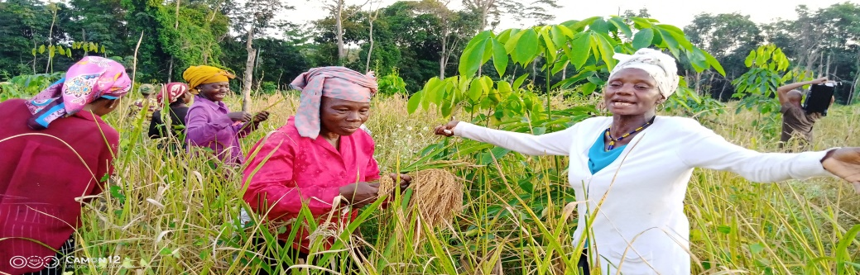
A proud farmer rejoicing for a great increased in her rice yields this year.
Thanks to UMCOR Sustainable Agriculture Development program which is changing lives and empowering rural communities in Nimba County.

EDUCATION- Ministery of Education in its attempt to ensure safety of the school enviroment has put in place preventive protocals for Covid-19. The misintry is distributing locally made Fast-Pedal Hand Washing Station and health kits, with masks to all schools, public, private, and faith-based schools in the country; it has announced a tentitive reopning date for academic 2020/2021 of which classes are expected to begin Dcember 14, 2020.

The impact of Covid-19 is greatly on students and parents, the major problem particularly in rural areas. Families cannot pay tuition for their children to enter school this school year due to the pendamic which had created financial chllenged for parents.
Therefore, we are making SPECIAL APPEAL for scholarship support for our students and Christmas camp for December 22-27, 2020.
The donations made toward the camp will help us work with children and youth to Know Christ and to Make Him Known
“Who are you when no one is looking?” The theme of the camp- text Genesis 9:5-

Opportunities to support our Ministry:
- Scholarships: We are asking for sponsors to donate funds to help our needed students who would otherwise not have the opportunity to be in school 2020/2021
2. A special appeal for donation for Christmas camp and Christmas gift package to our children
3. Sustainable agriculture program to empower local farmers and community groups
4. Ganta Hospital for poor patient fund, medical supplies and other support of the hospital
5.Dormintory construction to house students at the Gipo Vocational School from far distances around nimba county and in Liberia.

Your Support Matters!
When you partner with me in God’s mission anything is possible! Can you help me to meet my year end goal? I’m only a little over $10,000 away!
I would not be able to serve in Liberia if it were not for the generous supports of people like you and I’m still trying to make it to my end of the year goal. If 100 people gave between $50 and $100 in the month of December I would make it.
I pray that you would please consider making an online donation to my personal missionary advance number # 13035Z and for
Advance Special: #14369T, Ganta Mission Station support
On Giving Tuesday, you can give love, joy, hope and peace,
by clicking here http://umcmission.org/givelove -Give to mission.
Please know that the donations made to my personal advance number do not come directly to me but support the cost of missionaries like myself who are serving all over the world. Each missionary has the goal of raising $25,000 annually.
Thanks to our partners, churches and friends for your prayers and financial supports throughout the year which helps us to be in ministry with God’s children for the advancement of God’s Kingdom here on earth. Our appreciations and thanks to our volunteers in mission, those churches in covenant relationship with us, scholarship sponsors, the donations of advance special gifts ,I’m grateful for the continues partnership and support, which gives us hope and strengthen my ministry?
HAPPY ADVENT SEASON!

