REV. PRISCILLA LEGAY-Gilayeneh
GLOBAL MINISTRIES MISSIONARY ASSIGNED TO LIBERIA
GANTA UNITED METHODIST MISSION STATION
JULY/ AUGUST 2020, NEWSLETTER
Advance Special: #14369T
Email: pjaiah12@gmail.com
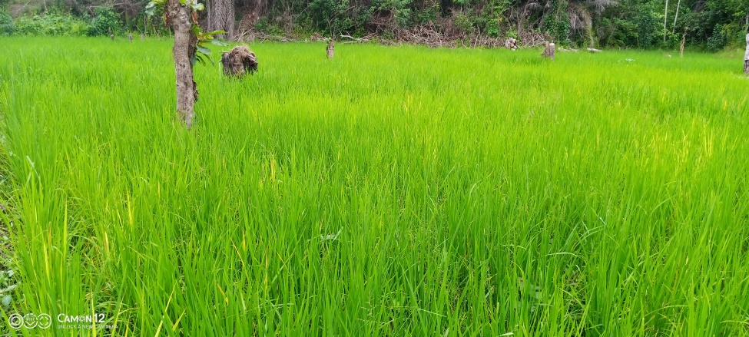
The impact of Covid-19 on farming in Ganta/ Liberia
Warm greetings to you on behalf of our Ganta Mission Station family!
The phrase global became real through the Covid-19 pandemic; the virus brought the world so close together as the global pandemic spread from one county to the other and gave us a sense of oneness, we are the same human beings created by God in the beginning. Genesis 1: 27- God created human in his own image, in the image of God created male and female. The virus is affecting our health, relationships, economy, and the agriculture sector not only in Liberia, but every country has been totally affected by this deadly pandemic.

The Ganta Mission Station is one of our ministry areas and is involved in Agriculture and working with local farmers by training and teaching them how to improve their crops production. The goal is to engage the farmers in sustainable farming, producing cassava, sweet corn, beans, and tomatoes, bee keeping, and raising snails and pigs.
Agriculture is the primary livelihood for more than 80 percent of Liberia’s population. For many households, especially in the rural areas, subsistence farming is the primary source of income. More people engage in cassava, rice, oil palm, rubber, cocoa, and vegetable farming, and petty business.
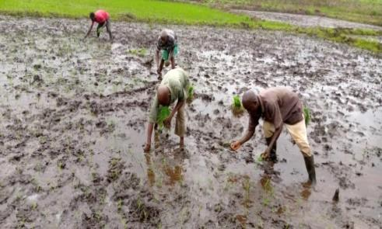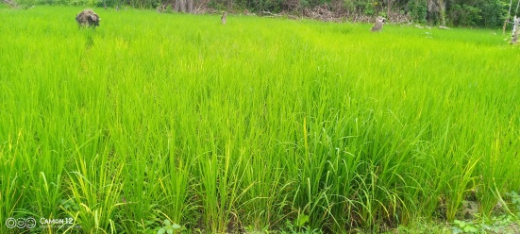
Planting Swamp Rice in the plots, May 2020/ this is the level in July
In Liberia, the lockdown and imposed curfew from 3:00 pm - 6:00 am affected everyone- school children, business people, farmers, market women, and petty traders (mostly women). In Liberia, the farming season begins in January. This year the completion of clearing and cultivating land was delayed due to the restricted hours and caused a reduction in crops production. Nevertheless, the curfew didn’t totally stop the Ganta Mission Station from working with local farmers through the Food Security Agriculture Program, but it slowed the farming activities down to 60 percent. The good thing was our training for local farmers in pig farming and beekeeping was conducted in January 2020. Only the training for chicken and vegetable farmers was put on hold because of the Covid-19 pandemic.
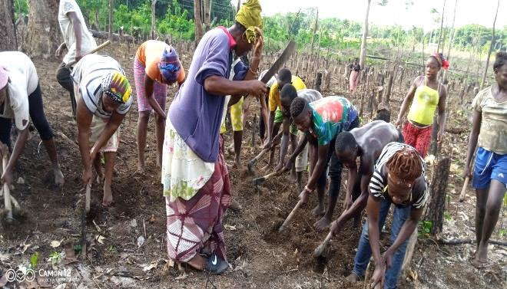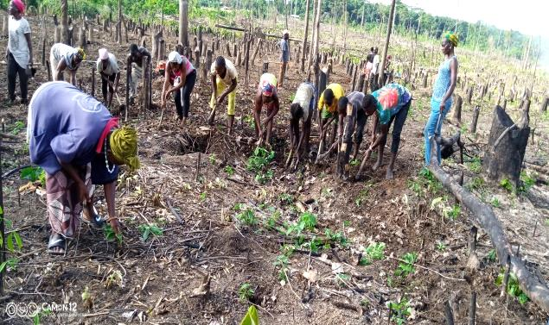Traditional farming, upland rice is planted by hands known as scratching. One of our local farmers
Is part of this working group known as coup about forty people working on his farm.

During the lockdown our office and the farmers worked from 7:30 am - 2:00 pm daily. We observed the curfew and tried to keep safe. The farmers cultivated the land for planting beans, cassava, rice, sweet corn, tomato, and cucumber. They constructed bee hives and pig pens. There’s a saying in Liberia that, “In time of peace, prepare for war.” Although the Covid-19 pandemic is affecting every area of our lives, the farmers used the little time to plant and now they are harvesting beans, sweet corn, tomatoes. They started planting rice by hand from the beginning of June and ended the planting by the 26th of July- our Independence Day
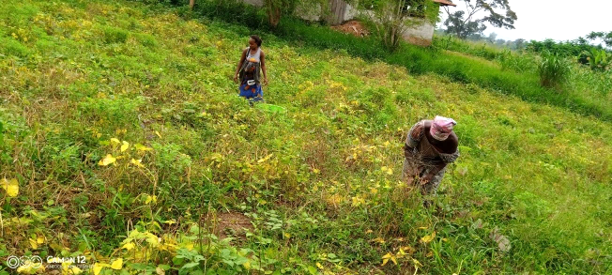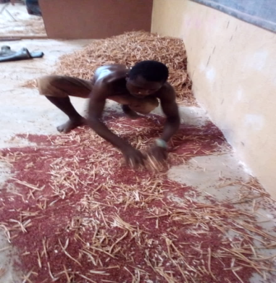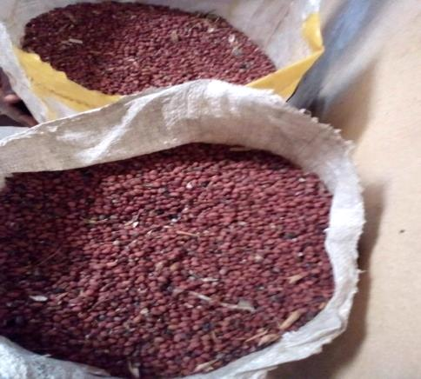
Local farmer family, harvesting beans and he’s threshing it.( UMCOR Food Security program)
The Food Security is Project impacting family lives; we distributed bee hives and also distributed piglets to farmers after helping 15 farmers to construct pigpens. Thank God to UMCOR, our partner, for being in ministry with the people through providing the Food Security Grant to build the capacity of local farmers, giving them training to help increase their cash crop yields through greater food production.
From Farm to Market!

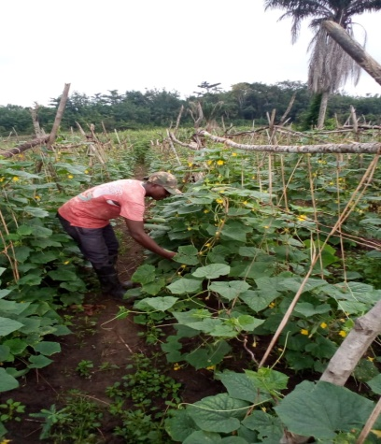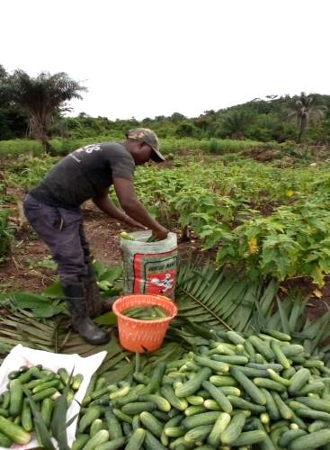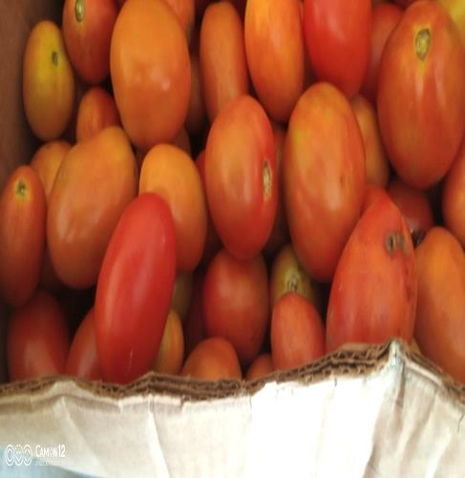

Gipo Vocational Training Institute; Agriculture Practical teacher desired to remain on campus during the Covid-19 lockdown to grow vegetables, cassava and rice for sustainability for the school. He is harvesting his first crops cucumber and tomatoes for market but challenging to get it sold.

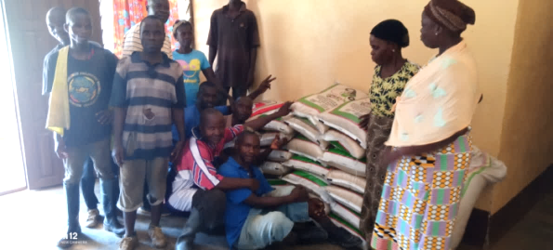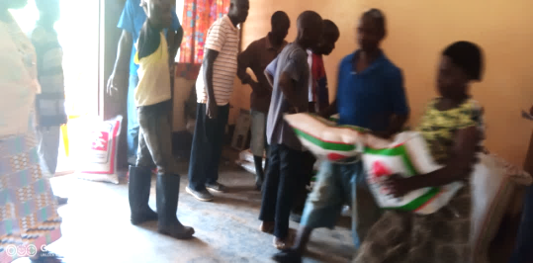
The distribution of rice donation made by Charles and Janice Gallaher in the amount of
three hundred dollars ( $300)

The rice was purchased with the fund donated and distributed among the Ganta Mission Station Staff, Pastors, and the Elderly from the church
A special thanks to Pastor Zach Fitzpatrick and members of Elizabeth Lee UMC in Chickamauga or their generosity during this pandemic that created hardship for our people.
The Ganta Hospital remained open during the Covid-19 pandemic and was able to provide health services to the people in Ganta and all parts of Liberia. The hospital had four Covid-19 patients. Three died and one recovered. The patient who recovered happens to be one of our lab technicians from Ganta Hospital.
Ganta United Methodist School and the Winifred J. Harley Collage of Health Sciences have been closed since March 2020. On June 29th, all the 12th graders in Liberia were called back to school in order to be able take their West African Senior Schools Certificate Examination (WASSCE) from August 17 – September 2, 2020. On July 27th , 2020 the Minister of Education in consultation with the Health Ministry officially announced the reopening of schools in Liberia from 6th grade to 11th grade to complete the end of the academic calendar for 2019/2020, commencing on August 10th 2020. The elementary level from 1st to 5th grade will not enrolled in classes but schools authorities are urged to give lessons as homework.
Miller McAllister United Methodist Church- was among churches that were closed down and just started having services in June, 2020, observing the Covid-19 protocols by having more than one service, wearing masks, social distancing.
Thank you, our partners and friends, who continues to support us with your prayers and financial donations, enabling us to carry on the various ministries,: agriculture, scholarships, health care delivery, nursing school and vocational education to the underprivileged young people.
Please support us by giving to: the Advance: #14369T, Ganta Mission Station support
The Special Advance # 13035Z for Missionary Support in my name:

In Mission Together,
Priscilla Legay- Gilayeneh

.

