Project AGAPE
In Artsakh Republic (a.k.a. Nagorno-Karabakh)
Cattle Project

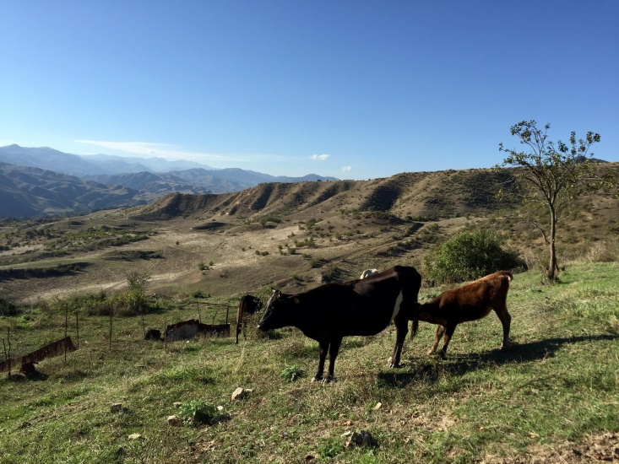

Project AGAPE uses the model of Heifer International to give cows to refugee families so that they may learn to become self-sufficient.
For a donation of $1000, a cow is purchased, feed for the winter is secured, materials for a stall are obtained, and a veterinarian is retained for necessary services. Each family is trained in animal husbandry. When the cow gives birth to her first heifer, that heifer is given to another family.
To donate to the Cattle Project, send your donation to the NC Conference of the UMC designated for the Conference Advance #S-00259 AGAPE Cattle Project.

Project AGAPE
In Artsakh Republic (a.k.a. Nagorno-Karabakh)
Agriculture & Development Project

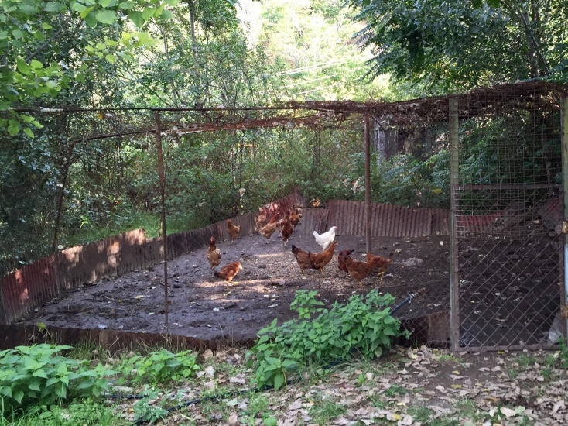

Project AGAPE uses the model of Heifer International to give chickens to refugee families so that they may learn to become self-sufficient.
For a donation of $20, five laying hens are given to a family. Families are taught how to raise the chickens, use and market the eggs, and how to keep their flock going so that they might eventually share some of their chickens with another family.
To donate to the Agriculture & Development Project, send your donation to the NC Conference of the UMC designated for the Conference Advance #S-00288 Project AGAPE. Please write “Agriculture & Development Project” on the memo line of your check.

