“We’re All In This Together”
Mission of Hope: Sierra Leone/Covid 19 Updates

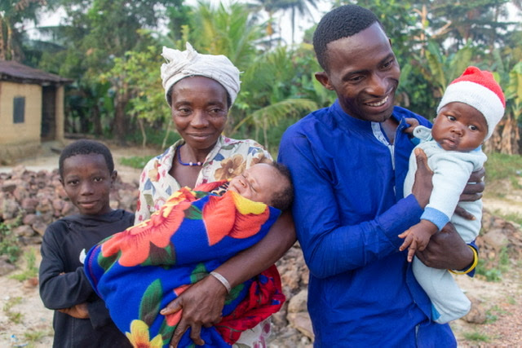

Covid-19 is a global pandemic, none of us are safe for long, unless we are all safe. This time the terrible virus apparently came to the US from Europe, or China. Next time it could easily come from Sierra Leone, just as Ebola did. Therefore, we must continue to support the health system and the people of Sierra Leone as well as at home. This is the goal of Mission of Hope.
While all of us have had our lives upended and many are facing economic hardship coping with the fallout of the covid-19 virus, there is an entirely different level of fear and suffering in Sierra Leone.
We know our compassionate donors are giving generously to help support those suffering here at home. Living in the relative wealth of the United States, we are somewhat equipped to respond to this pandemic. When people in the US have no money for food, there are food lines. When people in Sierra Leone can’t buy food, they become malnourished and occasionally starve to death. In America we can stock up on food and put it in the freezer. In Rotifunk there is no electricity and food is only purchased as needed for one or two days. Food supply in the markets is unreliable at best.
In the US we can spend $ billions to support businesses and increase manufacturing capacity. In fact, we have geared up to manufacture more sanitation supplies, masks, gowns, ventilators, etc. We have even built new temporary hospitals. Sierra Leone does not have the capability to do any of these things. In fact, at Rotifunk Hospital even the basic items are missing. Their needs list includes cleaning supplies, handwashing stations, money to make homemade masks, no-touch infrared thermometers and at least one ventilator. Yes, just one ventilator would save many lives.
As you support your local community please don’t forget your friends in Sierra Leone. They are desperate for our help. Please make a donation to Mission of Hope, PO Box 11103, Wilmington, NC. 28404
We are all in this together.

